
Early Years Learning in Mathematics community

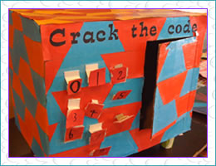
Professional Learning Resource
Crack the code
Children construct a play safe with a security panel attaching the digits zero to nine.

Crack the code enquiry
Can you guess the code using the digits zero to nine?
I am a four-digit number.
My digits add to 11
I have 2 even numbers and 2 odd numbers
My largest digit is 5
Is there more than one answer?
Can you make up some questions for a different code?
Teachers should comprehend what students need to understand before and after this task. As part of the community other educators can make suggestions to similar tasks, pre-tasks and tasks that will scaffold students' understanding once they have developed this concept. For example, you may choose to use two-digit numbers with younger students.
Especially, in the early years, mathematical tasks need to be hands on, often designed to develop understanding of the same concept. Effective teachers often repeat an activity in a similar way with different materials.
As other educators share ideas in this conversation or with other ideas, a specialised language teachers use to support numeracy with young children will also assist their’ pedagogical content knowledge.
This community can support the sharing of these ideas through conversations, sharing of ideas, resources, photos and descriptions of numeracy tasks.

Community shared resource – Sharyn Livy, Early Years Mathematics Specialist

